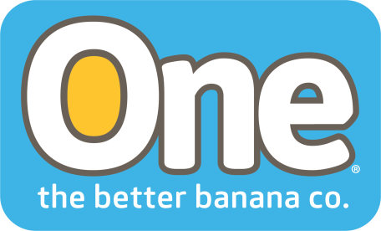

ONE Banana Reports on its Sustainability Programs in 2017
Coral Gables, Florida. July 20, 2018— The ONE Banana Company has issued its 2017 sustainability report covering the initiatives and sustainable practices that focus on the Sustainable Development Goals (SDGs) promoted by the United Nations General Assembly through Resolution 70/1: Transforming our world - the 2030 Agenda for Sustainable Development. Guatemala, Ecuador and Peru, countries where One Banana operates, are signatories to this resolution.
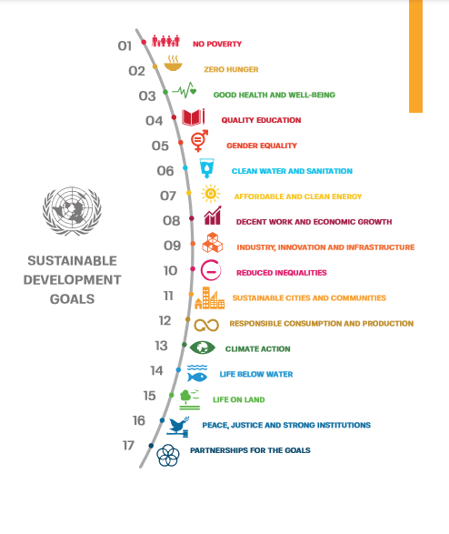

Here are some of the highlights of the report:
Labor Practices and a Living Wage
SDG #1: End poverty in all forms everywhere.
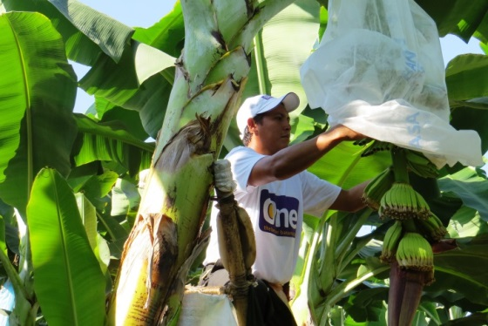
In 2017 ONE Banana created more than 9,000 direct jobs in their banana operations in Guatemala, Ecuador, the United States, Panama, Peru, and Europe. In contrast to the concept of a minimum wage, a Living Wage defines the income that an individual requires to support his/ her family at a given moment and in a specific place to allow that individual to live a full and decent life.
Another practice related to this SDG is the development and promotion of local small and medium-sized companies, like the 2,692 suppliers that provide ONE Banana with the various resources and inputs required in their operations.
Good Health and Well-Being
SDG #3: Ensure healthy lives and promote well-being for all at all ages.
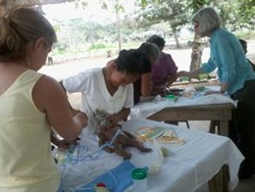
ONE Banana operates a medical clinic that is part of their comprehensive vision to provide access and health coverage in the area of influence of their operations. The clinic is located in the Southwestern region of Guatemala, where more than 30,000 people live.
The project was made possible by working with the University of Colorado, in the United States. They provide technical assistance and resident doctors for patient care, along with Guatemalan doctors and nurses. The clinic is available to employees, their families and members of surrounding communities giving them access to high-quality medical services at very affordable prices.
The Madres Sanas (Healthy Mothers) program directly addresses the health and well-being of mothers. Aimed at pregnant women, it teaches mothers to identify danger signals during pregnancy, pre-natal care, post-partum depression, danger signals in new-born babies, adequate nutrition, and breast-feeding. Medical control and exams are carried out during pregnancy and household visits provide pregnancy control through medical exams.
In 2017 there were 312 mothers in this program and 982 household visits were made.
Gender Equality
SDG #5: Achieve gender equality and empower all women and girls
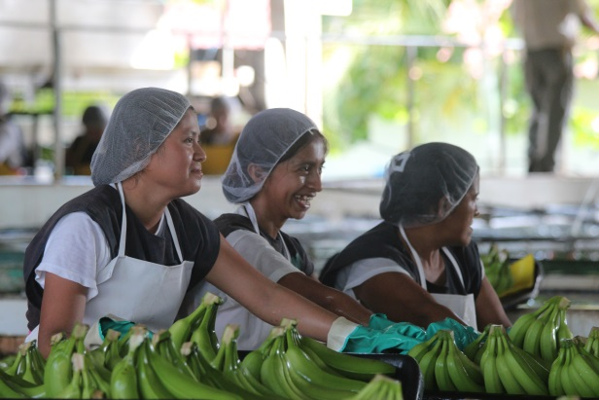
ONE Banana ensures the participation and empowerment of women through employment, which gives them the opportunity to grow professionally and bring development to their families and communities.
- 51% of the packing facility workers are women
- 16% of our field and packing facility workers are women
- 17% of our Executive Committee members are women

About ONE Banana
ONE Banana is a sustainable grower, shipper and distributor of tropical fruit with operations in the United States, Guatemala, Europe, Peru and Ecuador. It has emerged as a leader in socially responsible and environmentally sustainable farming. For more information about ONE Banana please visit our website. https://www.onebananas.com
Contact information: info@onebananas.com

